SOFTWARE REQUIREMENT SPECIFICATIONS (SRS)
FOR

REVAMPING THE BI DASHBOARD WEB APPLICATION DESIGN & DEVELOPMENT
SUBMITTED TO
IVTECH COMPUTER SYSTEMS LLC

Version: 1.0

11th MARCH 2025

Prepared By:
SPEC INDIA

Revision History

Date | Version | Author | Created / Updated / Reviewed / Verified / Approved By
10-03-2025 | 1.0 | Parth Jotangiya | Initial Draft
11-03-2025 | 1.0 | Yaman Kavishwar | Reviewed and approved

Table of Contents
Contents
1. Introduction 4
1.1. Project Scope and Objectives 4
1.2. Items outside the Project Scope 7
1.3. Project Deliverables 7
1.4. Definitions, Acronyms, and Abbreviations 8
1.5. References 9
1.6. Project Approach 9
1.7. Security, Best Practices & Supported versions 10
2. User Descriptions 10
3. System Requirements 11
3.1 Settings > Manage Users Page 11
3.2 Settings > Roles & Permissions Page 15
3.3 Settings > Manage Users > Role Assignments to a Specific User 20
3.4 Settings > Multisite Setup Page 22
3.5 Login Page 24
3.6 Menu Items for BI Dashboard Web Application 26
3.7 Profile Page 28
3.8 Change Password Page 29
3.9 Configurations > Manage Devices Page 30
4. System Architecture 34
5. Assumptions, Dependencies and Constraints 36

Introduction

Project Scope and Objectives

- The purpose of this project is to revamp an existing BI Dashboard Web Application by enhancing the user interface & experience which will require minimal user’s inputs to perform the required steps.
- This requirement includes enhancing the current application with existing features and functionalities as specified by the client.
- These enhancements will help their customers to view widgets & manage their site wise configurations effectively.
- This application is tailored for their customers. It will be web-based and accessible exclusively through web browsers. Additionally, it will provide the capability to be installed on a customer’s local machine via a single executable file (e.g.: .exe / .msi).
- The .exe or .msi file will handle the automatic installation of all necessary files, configurations, and dependencies on the customer's local machine. Once installed, the BI Dashboard Web Application will be executed through the customer's web browser, operating within their local environment only.
- This document outlines the requirements for BI Dashboard Web Applications to be developed for IVTECH COMPUTER SYSTEMS LLC.
- The Requirement is present in the “Technical Requirements Doc R2” document shared by IVTECH COMPUTER SYSTEMS LLC, which contains information for BI Dashboard Web Application modules related to the following:
- User Login:
  - Users can log in using their credentials.
  - An admin user can reset any user’s password (Forgot password).
  - Admin users can change passwords for any specific user.
- User Management:
  - Add/Update/Delete users.
  - Assign Role - Permissions to Users to access camera/floor/zone/reports.
- Camera Management:
  - Add/Update/Delete camera.
  - Listing of Cameras with search/filter.
- Settings:
  - Upload Customer Logo.
  - License Management.
- Site and Zone Management:
  - Add/Update/Delete Site.
  - Add/Update/Delete Floor Plan.
  - Add/Update/Delete Zone on Floor Plan.
  - Add cameras to zones.
  - Camera rotation.
  - Map integration with static map images.
    - Imp Note:
      - For the Map Integration, the user needs to be online once, maybe while creating the Site to download the map images. Otherwise, we cannot identify which country/region/area images need to be downloaded to make the map work with static images.
      - For now, we will go for Open source to achieve the functionality of Offline maps. This is the subject of exclusive R&D; hence the final selection of the open-source solution will be done post R&D and discussion with the client team.
- Dashboard:
  - Report Filtering
  - Export to PDF/excel/csv.
  - Camera – No. of Camera Installed
  - Camera – No. of Camera Online/Offline
  - Camera - Online vs Offline Ratio
  - Camera – No. of Camera by Model Type
  - Camera – No. of Camera by Feature type
  - Site - Total Capacity
  - Site - Capacity Utilization (%)
  - Site - Most vs. Least Day for Capacity Utilization
  - Site - Zone-wise details for Max Capacity, Utilization, % (Table)
  - People Counting - People In
  - People Counting - People Out
  - People Counting - Avg. People In/Out in Day with Min and Max Count
  - People Counting - Cumulative People Count for Time
  - People Counting - Zone wise.
  - People Counting - Gender-wise.
  - People Counting - People with and without Mask/Helmet
  - People Counting - Most and Least Count Day for Specific Male and Female
  - People Counting - Slip and Fall Count for People with Gender
  - People Counting - New vs Total Visitors
  - Retail & Business AI Pack - Shopping Cart Counting
  - Retail & Business AI Pack - Heatmap for shopping cart
  - Retail & Business AI Pack - Queue events for shopping cart
  - Retail & Business AI Pack - Queue events for people
  - Retail & Business AI Pack - Blocked exit detection
  - Vehicle (Traffic (ITS) AI pack) - Vehicle Count (Min, Max, Avg. per Day)
  - Vehicle (Traffic (ITS) AI pack) - Vehicle by Type
  - Vehicle (Traffic (ITS) AI pack) - Vehicle In/Out
  - Vehicle (Traffic (ITS) AI pack) - Vehicle in Wrong Direction
  - Vehicle (Traffic (ITS) AI pack) - Stopped Vehicle Count Time
  - Vehicle (Traffic (ITS) AI pack) - Speed Detection by Vehicle
  - Vehicle (Traffic (ITS) AI pack) - Avg. Speed for Vehicle
  - Vehicle (Traffic (ITS) AI pack) - Traffic Jam by Day
  - Vehicle (Traffic (ITS) AI pack) - Day-wise Traffic (Most and Least)
  - Vehicle (Traffic (ITS) AI pack) - Speed Violation by Vehicle
  - Vehicle - Vehicle U Turn detection
  - Vehicle (Traffic (ITS) AI pack) - Pedestrian detection
  - Vehicle (Traffic (ITS) AI pack) - Vehicle Turning Movement counts
  - Vehicle (Traffic (ITS) AI pack) - Vehicle Queue Analysis
  - Vehicle (Traffic (ITS) AI pack) - Vehicle Detection Heatmap
  - Factory & Safety AI pack - Detect Forklifts
  - Factory & Safety AI pack - Proximity detection (between people, forklifts, between a person and a forklift)
  - Factory & Safety AI pack - Forklift speed detection
  - Factory & Safety AI pack - Counting & Heatmap for forklift and people
  - Factory & Safety AI pack - Queue events for forklift and people
  - Factory & Safety AI pack - Blocked exit detection
- The list of dashboard widgets specified above includes existing APIs related to Crowd Management, Queue Management, Traffic (Vehicle), Retail, and Factory AI Pack. Which will be provided by the client only.
- Package creation:
  - Create a package to install the web application on Windows PC only.
- Data Ingestion:
  - Scheduled calling of Camera APIs to ingest data in the database.
- Camera API Understanding and Integration:
  - Details of the Solar Power and Battery Utilization will be shown on the dashboard through SNMP/API integration with the BMS and MPTT Controller (calling of camera API and just displaying the data available from API).
- Configuration:
  - Standard Backup and Restore.
- AI Box Integration:
  - AI Box integration, considering the addition of multiple cameras in a single AI Box and considering the cameras added in the AI Box to display Dashboard widgets data.
- Alexa Integration:
  - Integration with Alexa, so that when the Alexa device is connected, it will open the specific widget on voice command.
- 7 other key features:
  - Provide data for multiple lanes (8 lanes).
  - Show heat maps on the floor plans and particular zones.
  - Multisite-wise dashboard widget reports.
  - For Multisite should be filtered to select the widgets and show the difference between Full site, single-zone, and Multizone.
  - SSL / HTTPS set up, (The SSL certificate will be purchased by client only).
  - Need to have Event reporting details with filtration with separate widgets or separate pages for this, and when the event is reported, need to have pre- and post-video of 5 seconds each.
  - SMTP server setup for email reporting with scheduled job (Required credentials will be provided by client only).

- The technology used to develop web applications will be:
Front-end | React.js
Back-end | .NET Core + Web Api (using C#)
Database | MongoDB

Items outside the Project Scope

- Creation of APIs which will be directly interacted with AI camera managed by Hanwha.
- SPEC INDIA will only utilize camera APIs managed by Hanwha and will replicate/ingest the necessary information in the database (if required) & display that required information on the web application.
- Multilingual support for web application. Application will be only in English language.
- Responsiveness to Tablet & Mobile. Application will be supported to desktop computer screen only.
- The development of Mobile Application for Android and iOS native integration will be out of scope.
- QA Testing is out of scope because client team will do it from their end.
- Failover plan for the database in case of any future failures.

Project Deliverables

- SPEC INDIA will be delivering below items as part of project deliverables:
  - System Requirements Specification (SRS) Document.
  - UI/UX (Figma) Design.
  - Source Code files.

Definitions, Acronyms, and Abbreviations

Definitions, Acronyms and Abbreviations
React.js | A JavaScript library for building user interfaces, particularly single-page applications (SPAs) with component-based architecture.
JSX | JavaScript XML, a syntax extension for JavaScript used in React to describe UI elements in a syntax like HTML.
Component | A reusable UI element in React that can be a class-based or functional component.
State | An object that stores dynamic data in a React component, influencing its rendering.
Props | Short for "Properties," used to pass data between React components.
MongoDB | A NoSQL database that stores data in JSON-like documents, known for its flexibility and scalability.
Collection | A group of MongoDB documents, like a table in relational databases.
Document | A single record in a MongoDB collection, stored in BSON format.
Schema | A structure defining the shape of documents in MongoDB, typically enforced using Mongoose in Node.js applications.
.NET Core Web API | A cross-platform, open-source framework for building RESTful web services using C# and .NET Core.
Controller | A class in .NET Core Web API that handles HTTP requests and responses.
Middleware | Software components in .NET Core that process HTTP requests and responses in a pipeline.
Entity Framework (EF) Core | An Object-Relational Mapper (ORM) for .NET Core, enabling database operations using C#.
DTO (Data Transfer Object) | A design pattern in .NET used to transfer data between layers of an application.
REST API | Representational State Transfer API, a web service architecture used for communication between clients and servers.
JWT (JSON Web Token) | A compact, URL-safe token used for authentication and authorization in web applications.

References

- During the requirement gathering meeting, the SPEC Team referred to their existing Vision Insight Web Application, which was installed and configured by Vijeesh on SPEC INDIA’s test machine. Additionally, they reviewed the reference video recorded and shared by Bala for the SightMind Web Application.

- Based on discussions and conclusions regarding the BI Dashboard Web Application with Bala & Vijeesh, the SPEC Team has applied their expertise to create a fresh and modern Figma design which is also approved by Bala, Vijeesh & Ganesh. Please find the attached link below:
  - Click here to Open newly created Figma Design for Bi Dashboard Web Application

Project Approach

- The proposed approach for executing this project is the Waterfall approach, in which requirements will be gathered, analyzed, and baselined to form the system's scope:
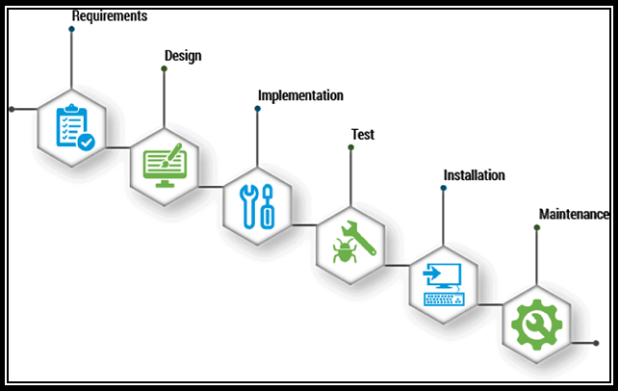

Security, Best Practices & Supported versions
  - The BI Dashboard Web Application will be protected by cyber security and vulnerability.
  - The BI Dashboard Web Application will work on desktop and laptop screens; it is not mobile & tablet responsive. It will work on the latest versions of Google Chrome, Mozilla Firefox & Safari.
  - The browser version at the time of UAT release will be considered as the latest support version.

User Descriptions

Sr. No | User Type | Activities in the system
1 | System User | - This user will exist only in the database, and the system will utilize this user's ID for data insertion or modification from the backend only.  - This user will not display in the BI Dashboard Web Application.  Example: Data Ingestion
2 | Super Admin | - This user will be the main user for the BI Dashboard Web Application. The source code will automatically configure the required information for this user, including roles and permissions, when deploying the application in a specific environment.  - This user will have full access.
3 | Sub-user | - A sub-user is a user created by an authorized user within the system.  - This user can be assigned any existing or newly created role by an authorized user.  - This user will have access to the application and its features based on the assigned permissions.

System Requirements

Settings > Manage Users Page

There has been provision in a system for Super Admin / authorized to create & manage the users. Super Admin has system level access and can manage each of sub users, roles & their permissions.

The system has a provision for super admin/authorized users to create & update the sub user and its information who has access to it. This is very basic and essential information of sub users.

Prototype:

- The screen below illustrates the list of all created users, including options for Search, Add, Edit, and Delete:
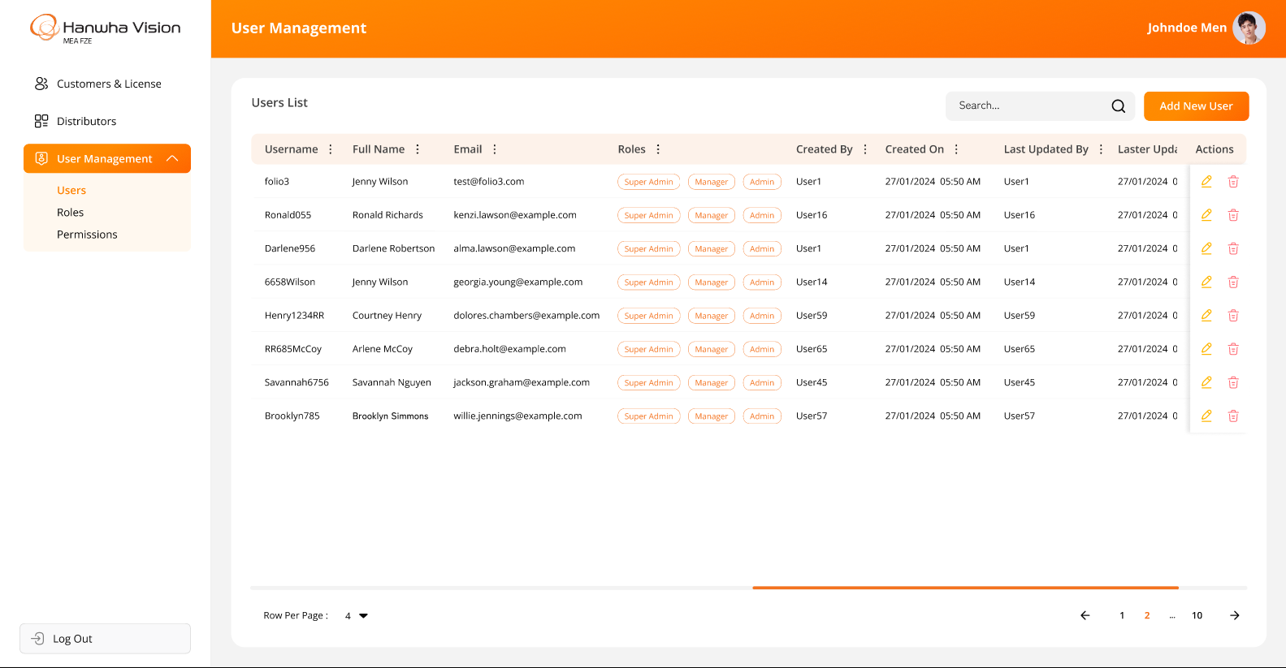

- The screen below represents the form for creating a new user in the Bi Dashboard Web Application, allowing users to enter relevant details and submit the information:
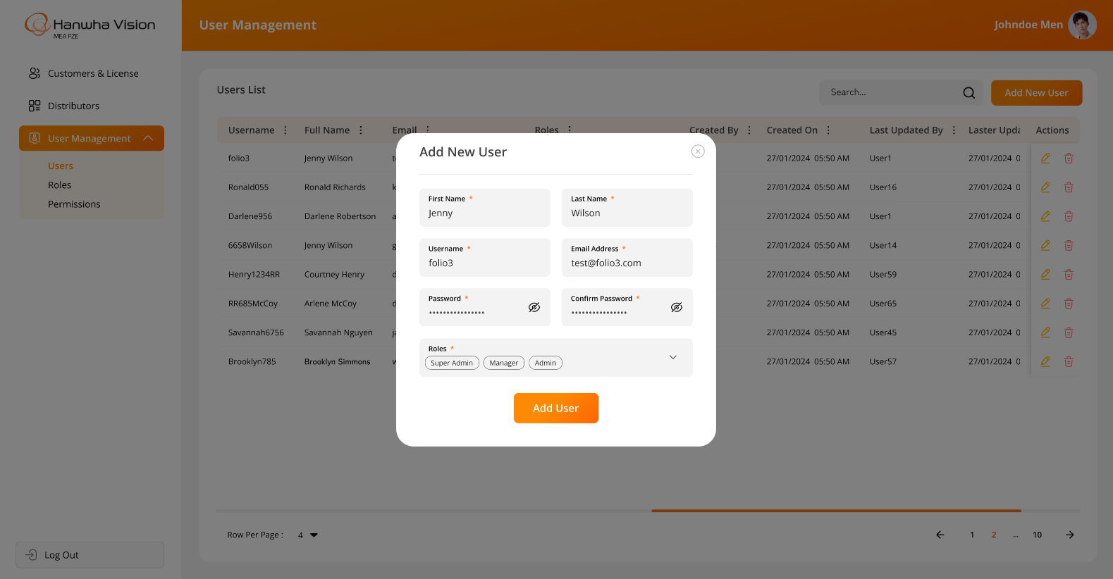
- The screen below displays the form for editing an existing user in the Bi Dashboard Web Application, allowing users to modify relevant details and update the information. Since all users can change/reset their passwords independently, the "Password" and "Confirm Password" fields should be hidden while editing user details:
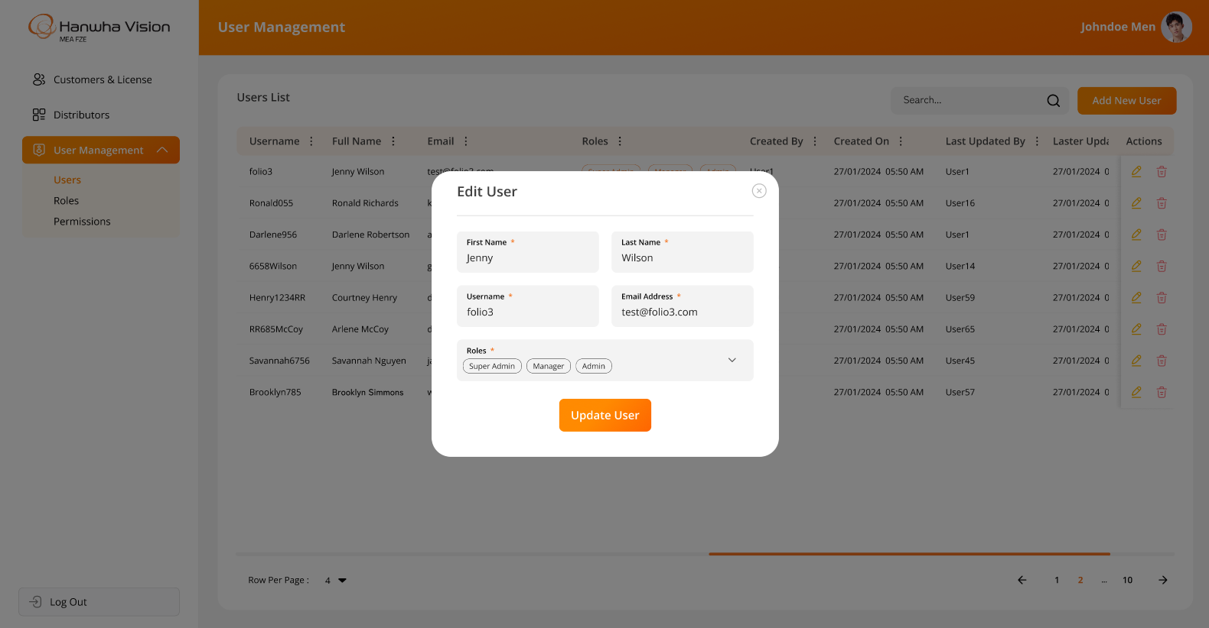

- The system will prompt for OTP verification when a user attempts to update the email address. OTP verification will not appear for other updates:
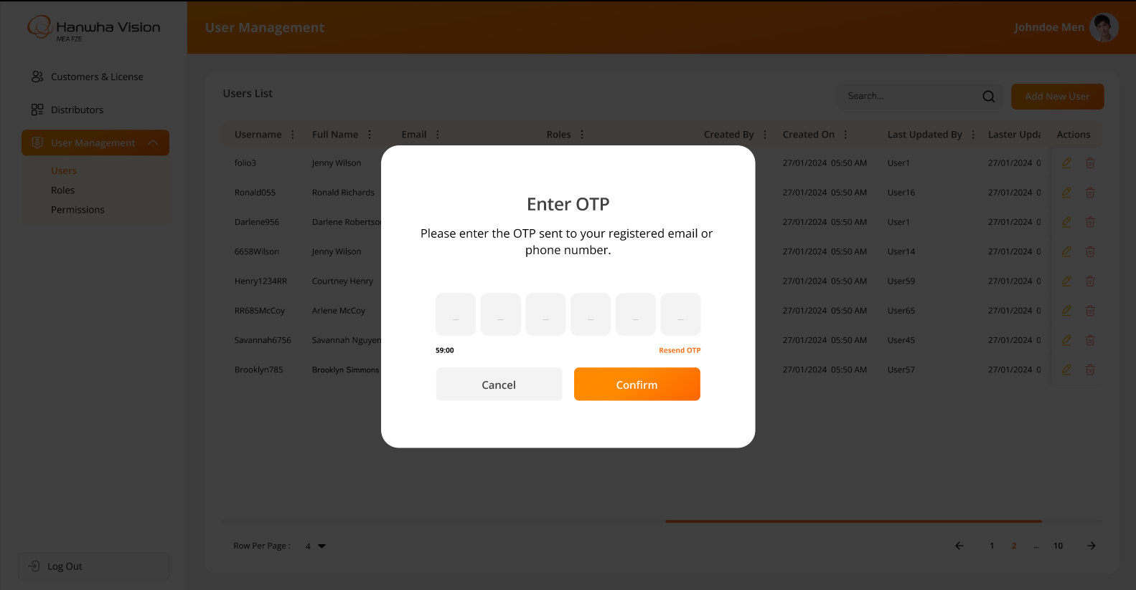
- The system will request confirmation when a logged-in user attempts to delete any user:
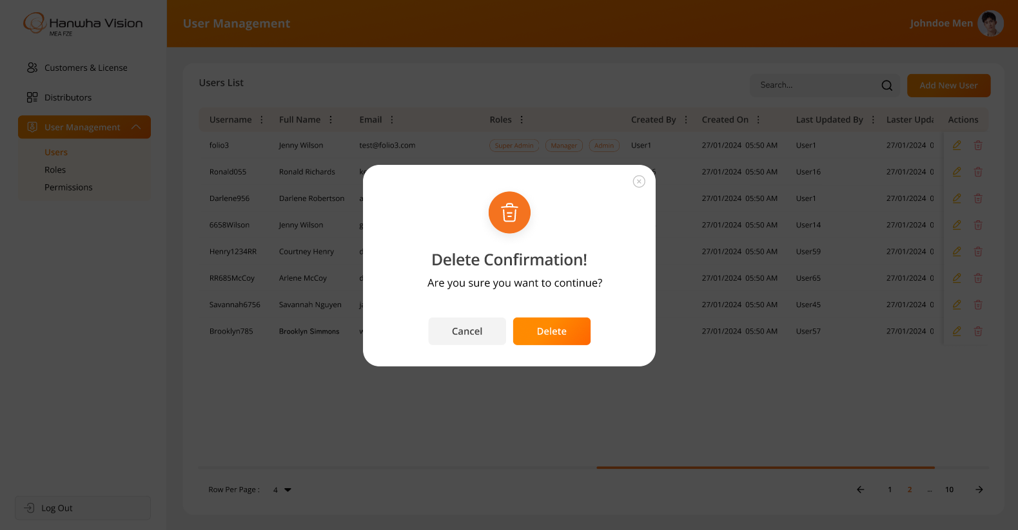

Business Rules:
- The system will display information and functionality strictly as per the above attached screenshots.
- The authorized user will have the ability to create and update sub-users.
- Password field will include following criteria:
  - Minimum password length: 8 characters
  - At least 1 uppercase letter
  - At least 1 lowercase letter
  - At least 1 numeric digit
  - At least 1 special character (excluding *)
- Authorized users will be able to assign multiple roles to the specific user.
- The “Add User” & “Edit User” screen will include following fields:
  - First Name*
  - Last Name*
  - Username*
  - Email Address*
  - Password*
  - Confirm Password*
  - Roles*
- Since the super user or authorized user can change the password of any specific sub-user, the "Password" and "Confirm Password" fields should be displayed when editing user details.
- The asterisk (*) indicates a mandatory field only.
- The system will not allow duplicate email addresses or usernames, as they must always be unique. These identifiers are essential for user authentication within the system.
- When a logged-in user (super user or authorized) attempts to delete another user, the system will prompt for confirmation. Once confirmed, the system will soft delete the user, meaning the record will remain in the database but will no longer be visible in the web application.
- The system will offer filter options (like Sort By ASC, Sort by DESC, Filter, Hide Column, Manage Columns) on specific columns using the MUI library, which is integrated into the entire web application. These filters will reset when the user reloads the page or navigates to another page.

Data Dictionary:

Settings > Roles & Permissions Page

The system allows super admins or authorized users to create and manage sub-user roles and permissions via the BI Dashboard Web Application.

Permissions can be assigned at the screen level with access types such as add, update, delete, and view, as well as for zones, floors, and widgets.

Authorized users can define roles with specific permissions and assign them to sub-users. Upon login, users can access only the functionalities allowed by their assigned role. This screen enables authorized users to update role-based permissions for screens, actions, zones, floors, and widgets.

Regarding Floor Plans & Zones Permissions:

- The system will maintain permissions at the Floor Plan and Zone levels only.
- It will be the responsibility of the admin user (who configures the application, users, and user permissions) to assign appropriate permissions for specific floor plans and zones to each user, especially in cases where a single camera is configured in multiple zones.
- As per Bala’s request, the system will not handle this scenario automatically.
- The system will display information strictly based on the assigned permissions at the Zone and Floor plan levels.

Prototype:
- The screen below displays the list of all created roles, with options for Search, Add, Edit, and Delete:
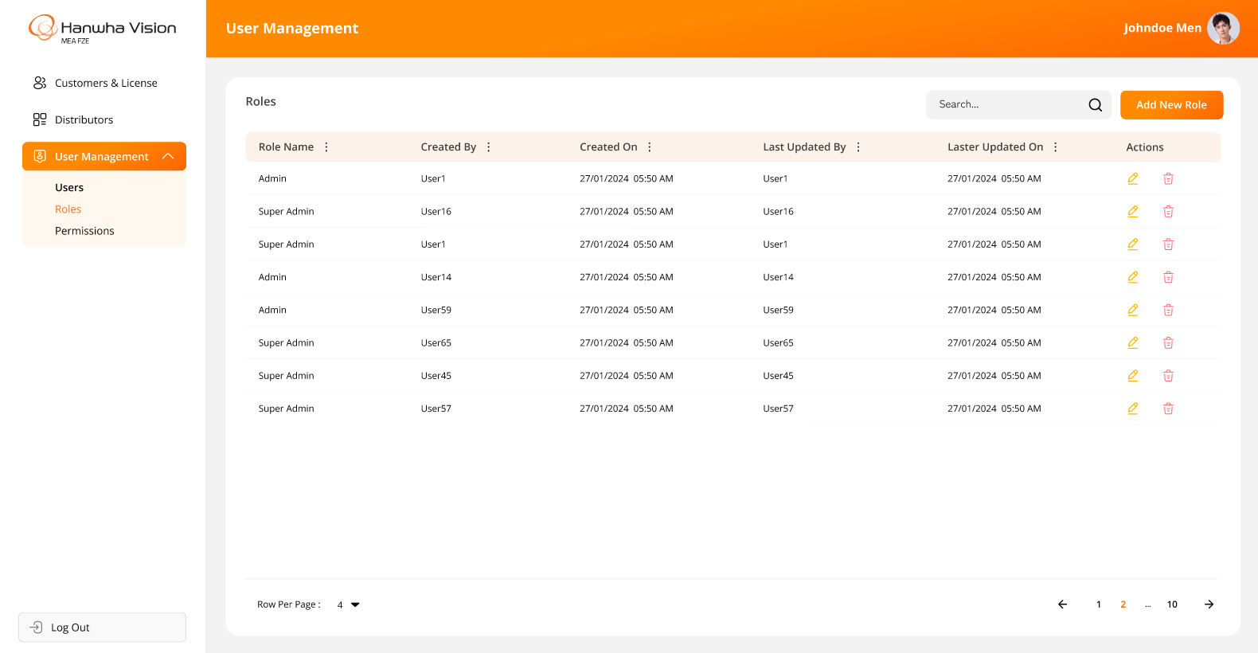

- The screen below represents the details for creating a new role in the Bi Dashboard Web Application:
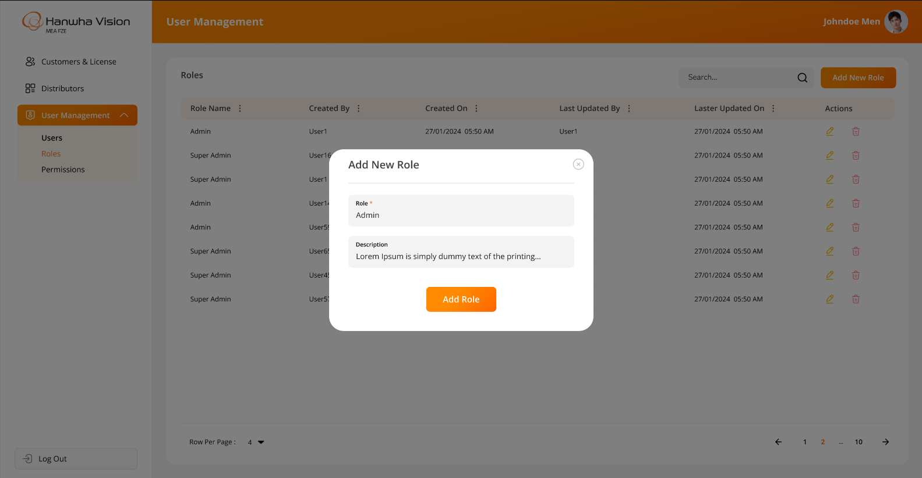
- The screen below represents the details for existing role while editing any specific role in the Bi Dashboard Web Application:
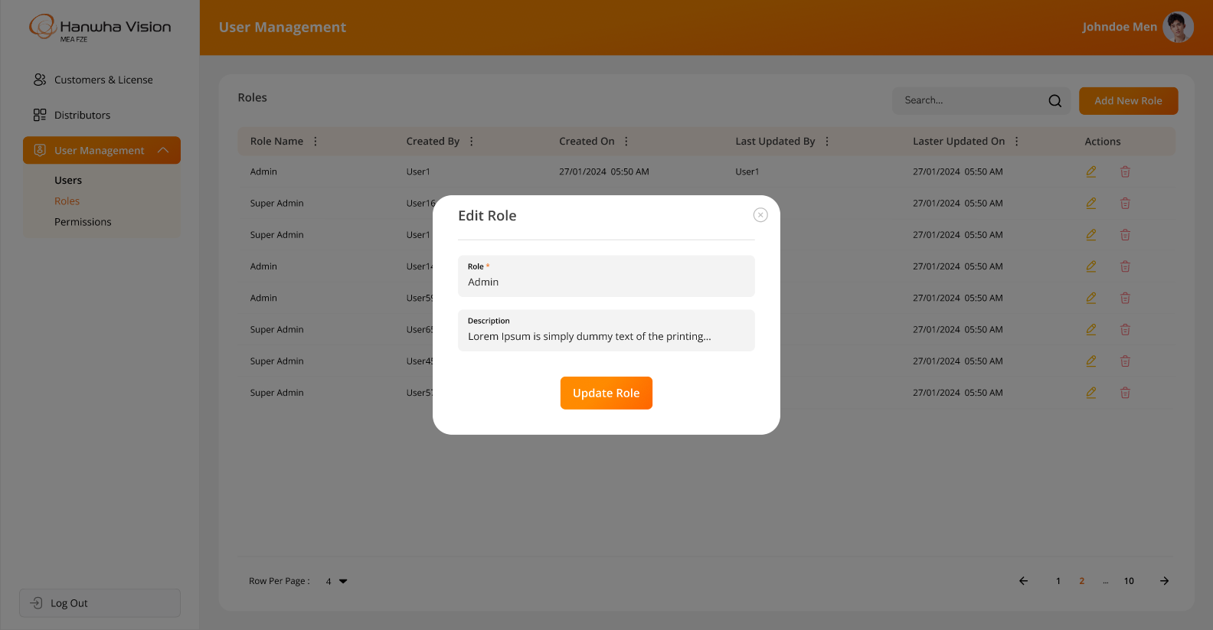

- The system will request confirmation when a logged-in user attempts to delete any role:
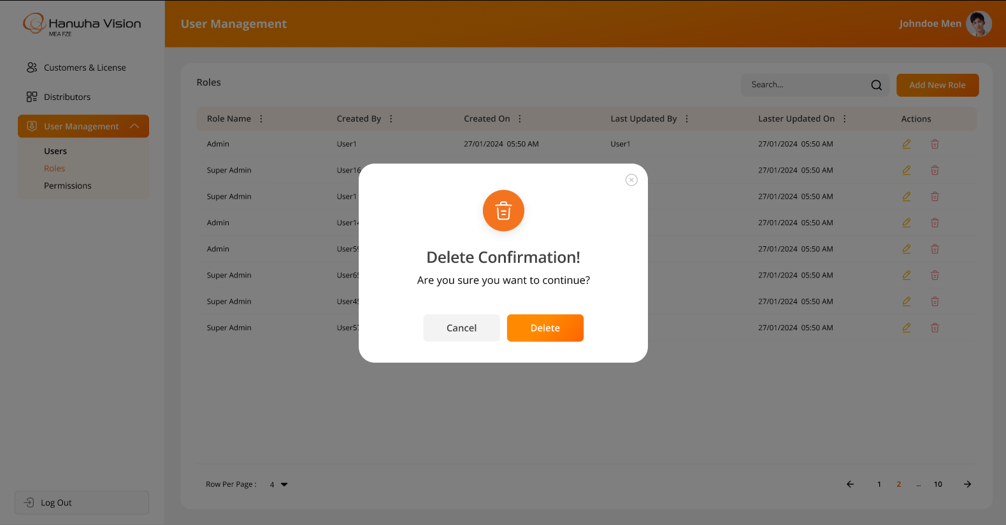

Business Rules:
- The system will display information and functionality strictly as per the above attached screenshots.
- Authorized users will have the ability to create, update & delete the roles within the system.
- The system will not allow the deletion of a role if it is already associated with any user.
- The system will prevent duplicate entries for roles or user-role assignments.
- When a logged-in user attempts to delete role, the system will prompt for confirmation. Once confirmed, the system will soft delete the user, meaning the record will remain in the database but will no longer be visible in the web application.
- The “Add Role” & “Edit Role” will include below field:
  - Role Name*
- The asterisk (*) indicates a mandatory field only.
- Authorized users can assign or update permissions for specific roles, defining access to various system functionalities.
- The system will ensure that permissions are role-based and cannot be assigned to individual users directly.
- The system will prevent the deletion of a role if it is already assigned to any user.
- The system should allow access only on those screens / actions / floor plans / zones / widgets which are allowed against the assigned role for logged in sub user.
- By Default, the super admin user will have full access to the admin application.
- The super admin / authorized user can assign screen-level permissions and corresponding actions (e.g., add, update, delete, view) to roles. However, the super admin / authorized user cannot assign permissions to actions that are not applicable to specific screens (For example, Insert/Update/Delete rights are not applicable to screens like Profile or Change Password. Therefore, the system should restrict the super admin / authorized user from assigning these permissions to roles for such screens).
- The system will maintain the history of each change in the permissions.
- Any updates to role permissions will take effect only after users associated with that role log in again.

Data Dictionary:

- An example of the screenMaster table is attached below to provide better clarity on the backend implementation:
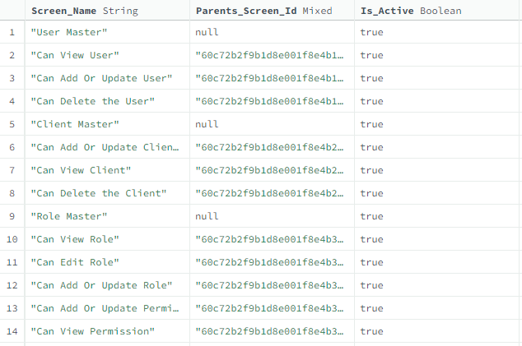
The above table contains a list of permissions that exist in the system, categorized by pages and their respective actions.

For example, the User Creation screen will have View, Add, Edit, and Update actions. Therefore, the following entries will exist in the table for the Users screen:

User Master
-> Can view user list
-> Can edit user details
-> Can add or update user details
-> Can delete user

Role & Screen Mappings: The table below provides information on screen-wise permissions assigned to specific roles:

Settings > Manage Users > Role Assignments to a Specific User

There has been provision in the system for super admin/ authorized users to manage role assignments to the specific user from the Bi Dashboard Web Application.

Once a role is defined, it is time to assign the responsibility to the respective users based on their designation and tasks.

This role assignment will be handled by super admin / authorized users. The system will allow access only according to the role assigned to the logged-in user.

Prototype:

- The screen below illustrates how an authorized user can assign one or multiple roles to a specific user while creating a new user from the Users Page:
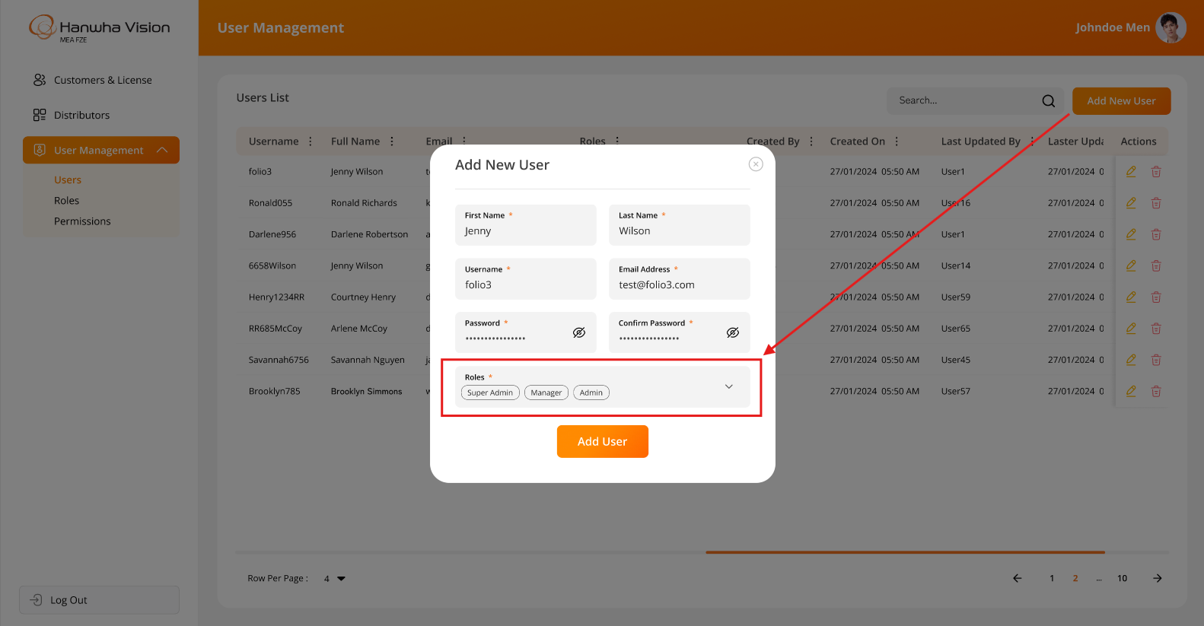

- The screen below illustrates how an authorized user can update or modify one or multiple roles for a specific user while editing their information from the Users Page:
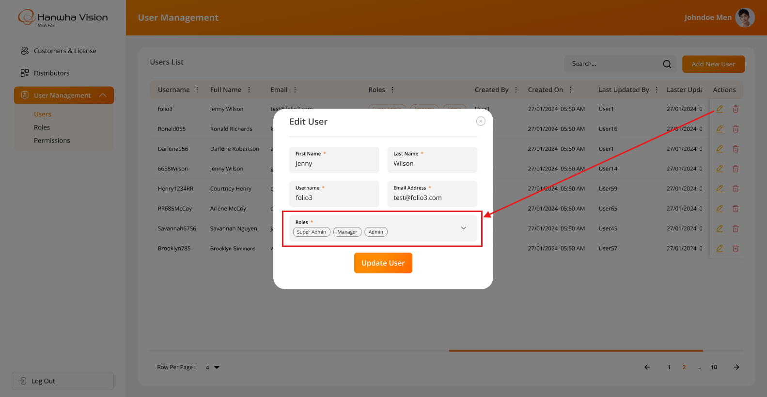

Business Rules:
- The system will display information and functionality strictly as per the above attached screenshots.
- Authorized users can select and assign specific roles from a dropdown list to any sub user.
- Authorized users can assign one or multiple roles to a specific user from the Users Page.
- Authorized users can update or modify user roles assignment from the Users Page.
- Any changes to the role assignment will immediately be reflected after relogging to the user after they log out and log back into the system.

Data Dictionary:
- The system will store the selected unique roleId(s) from the roleMaster table in the userMaster table. Refer to the highlighted row in GREEN in the image below for reference:

Settings > Multisite Setup Page

The system allows the parent site’s authorized user to manage single or multiple child and sub-child site configurations through the BI Dashboard Web Application.

The system will support multisite configuration up to three levels (Parent, Child & Sub-Child only).

This screen will be accessible by the parent site’s authorized user only. This means that a Child or sub-child site users cannot configure their own child sites.

Regarding Permissions for this Page:
It is entirely the super admin user's responsibility to grant screen-level permissions to the parent site’s user only while configuring the application on the customer site. The system will not handle this scenario automatically.

Prototype:

- The screen below illustrates how an authorized user can assign one or multiple roles to a specific user while creating a new user from the Users Page:

Business Rules:
- The system will display information and functionality strictly as per the above attached screenshots.
- Only the parent site’s authorized user will have the ability to configure this information. This means that a child site’s user cannot configure their sub-child; only the parent site’s authorized user will have that ability.
- Once the above configurations are completed, the system will allow the Parent Site’s authorized User to view data from all the configured child & sub-child sites only.
- The parent site’s authorized users will be able to add, edit, and delete the following details for each child or sub-child sites:
  - Site Name
  - Hosting Address / URL
  - Username
  - Password
- When the user enters the required details while adding or updating a child or sub-child site, the system will validate the connection from the backend and display an appropriate message on the screen, allowing the user to determine whether the entered information is valid or invalid.
- The system will provide the following options for managing child and sub-child sites:
  - Add Child Site
  - Edit Child Site
  - Delete Child Site
  - Add Sub-Child Site
  - Edit Sub-Child Site
  - Delete Sub-Child Site
- This screen will display a list of all configured child and sub-child sites, with the following options for each:
  - Edit
  - Delete
- The system will group child and sub-child sites and display them accordingly in a structured list.
- Each child site will have an option to add a sub-child site by clicking the "+" icon.
- When adding or updating a sub-child site, the parent child site’s name will be displayed on the "Add Sub-Child Site" & "Edit Sub-Child Site" screens as non-editable.
- The authorized user can search for a specific record using Site Name and Hosting Address.
- This screen will not support pagination but will allow vertical scrolling, enabling users to view all records smoothly.
- If at least one sub-child site exists for a child site, the system will allow users to expand and view sub-child sites within the list.

Data Dictionary:
- The system will store the selected unique roleId(s) from the roleMaster table in the userMaster table. Refer to the highlighted row in GREEN in the image below for reference:

Login Page

There has been provision in the system for all their users to login into the BI Dashboard Web Application.

This page will validate the user’s credentials when any user tries to login into the system by entering their own credentials.

Prototype:
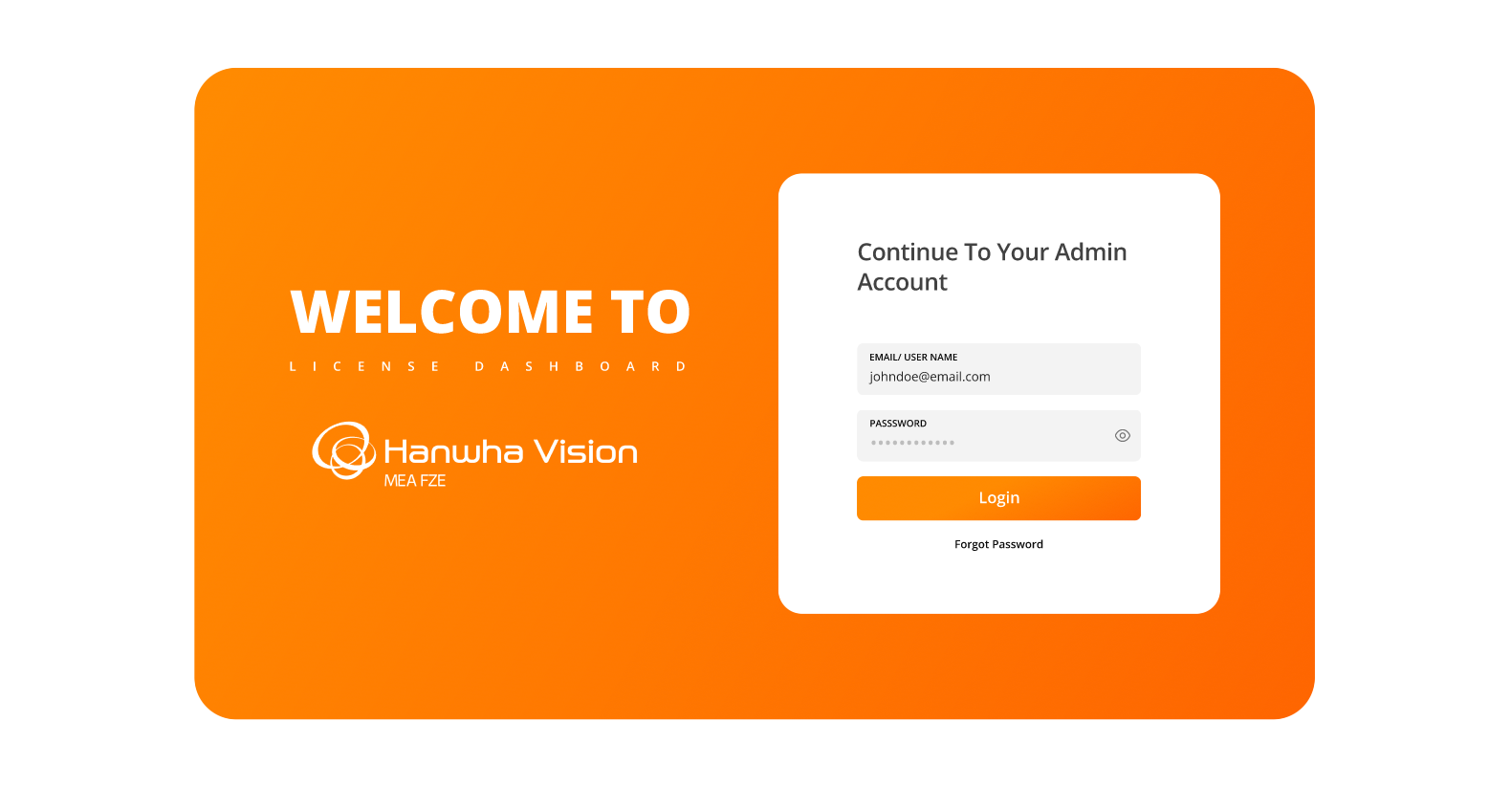

Business Rules:
- The system will display information and functionality strictly as per the above attached screenshot.
- The login screen will include a logo and text fields for entering the username or email address and password, along with a Login (Submit) button as well as “Forgot Password” link.
- Upon clicking the "Forgot Password" link, the user will see the following message, as sub-users cannot reset their own passwords. Only the super admin or an authorized user can change the sub-user's password:
“Kindly coordinate with your administrator to reset the password”
- Upon clicking the “Login” button, the application will validate the entered username or email address and password.
- If the credentials are successfully validated:
  - The application will check the user's authorizations and redirect them to the Dashboard screen.
- If the entered credentials are invalid:
  - The system will display an appropriate error message on the login screen.
- If the user is marked as Inactive/Deleted in the system:
  - They will not be able to login using their existing credentials.
  - In such cases, the user must contact the super user & authorized users for further assistance.
- The system will validate below highlighted fields while logging into the system.

Data Dictionary:

Menu Items for BI Dashboard Web Application

The system allows all users to log in to the BI Dashboard Web Application and access the following menus and options based on the specific assigned permissions:

The following options/menus will be displayed on the sidebar:
- Dashboards
- Configurations:
  - Manage Devices
  - Floor Plans & Zones
- Events
- Reports
- Settings:
  - Manage Users
  - Roles & Permissions
  - Multisite Setup

The following options/menus will be displayed when the user clicks on their profile image in the top right-hand corner:
- Profile
- Change Password
- Logout

Prototype:
- The screen below illustrates above mentioned menu items & options for Bi Dashboard Web Application.

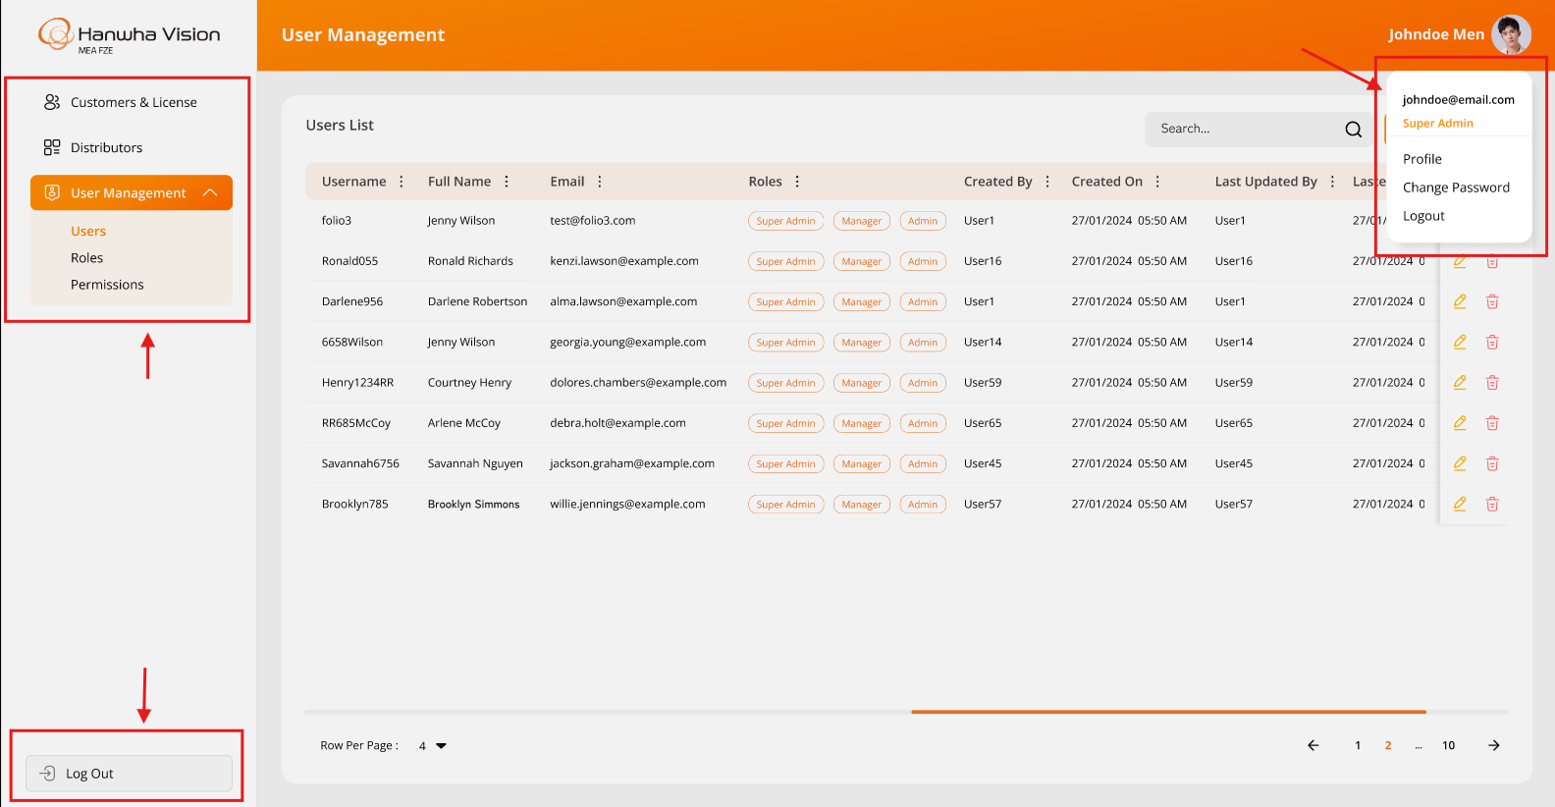

Business Rules:
- The system will display information and functionality strictly as per the above attached screenshot.
- The logged-in user will be able to access the above highlighted menus or options based on the specific assigned permissions only.
- All users will be able to access the following options:
  - Profile
  - Change Password
  - Logout
- The system will automatically hide any menus or specific actions on screens that the logged-in user is not authorized to access based on their assigned permissions.

Data Dictionary:
- It is not required to manage any data dictionary for menu items, as it will be handled directly in the frontend code only.

Profile Page

The system provides a feature for all users to log in to the BI Dashboard Web Application and access the Profile page.

This page displays details specific to the logged-in user only.

This screen can be accessed by clicking on the Profile link located at the top-right corner of the screen's top bar.

Prototype:

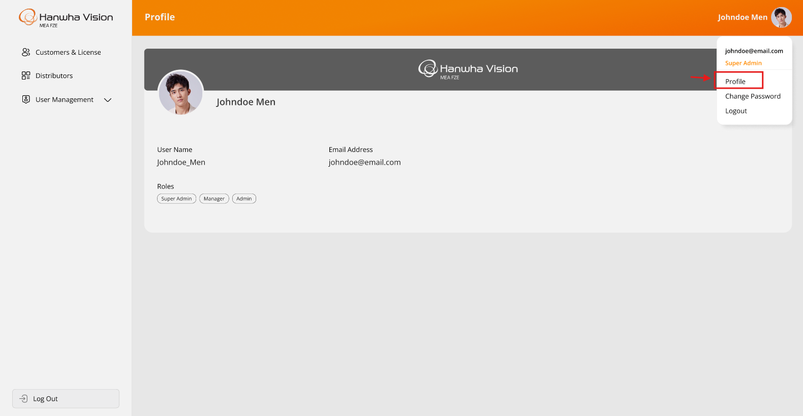

Business Rules:
- The system will display information and functionality strictly as per the above attached screenshot.
- The system will display information related to the logged-in user on this page. Which are enlisted below:
  - Profile Image
  - Full Name (First & Last Name)
  - Username
  - Email Address
  - Roles (which is assigned to logged-in user from the Manage Users page)
- This screen will allow logged-in users to only view their details except updating their profile image only.
- The user can update their profile picture by clicking on the current profile image and selecting a new one & the updated profile picture will be reflected across the entire system after re-logging in.
Data Dictionary:
- This page will display registered information for the specific logged-in user from the userMaster table only.

Change Password Page

The system will not allow users to change their own password from the BI Dashboard Web Application.

To reset or change their password, users must contact a super user / authorized. Only a super user / authorized can update or reset passwords from the Manage Users page.

Prototype:

- The screen below illustrates the message that will appear once the password has been successfully changed in the system:
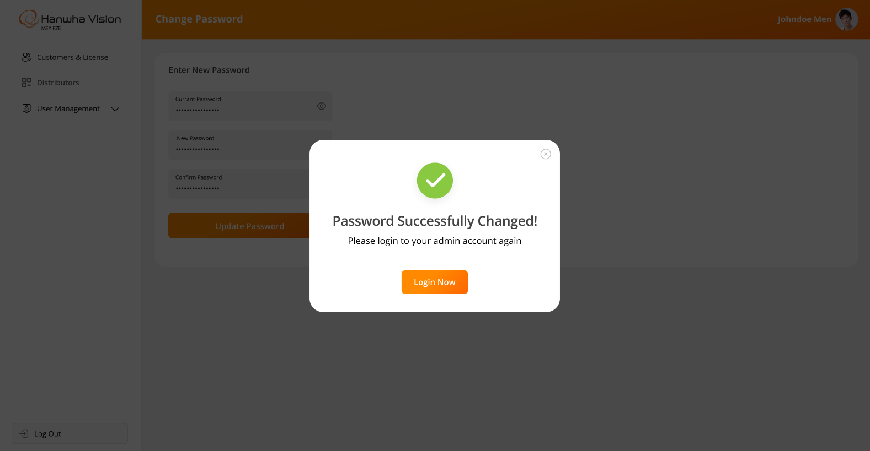
Business Rules:
- The system will display information and functionality strictly as per the above attached screenshots.
- All users will have access to this option.
- Upon clicking this option, the system will display the following message:
“Kindly coordinate with your administrator to change your password”

Configurations > Manage Devices Page

The system provides a feature for authorized users to create and manage distributors through the Bi Dashboard Web Application. This page will be accessible exclusively to authorized users only, with actions such as adding, editing, and deleting distributors displayed based on the permissions assigned to each admin user.

Prototype:
- The screen below illustrates the list of all created distributors, including options for Search, Add, Edit, and Delete:
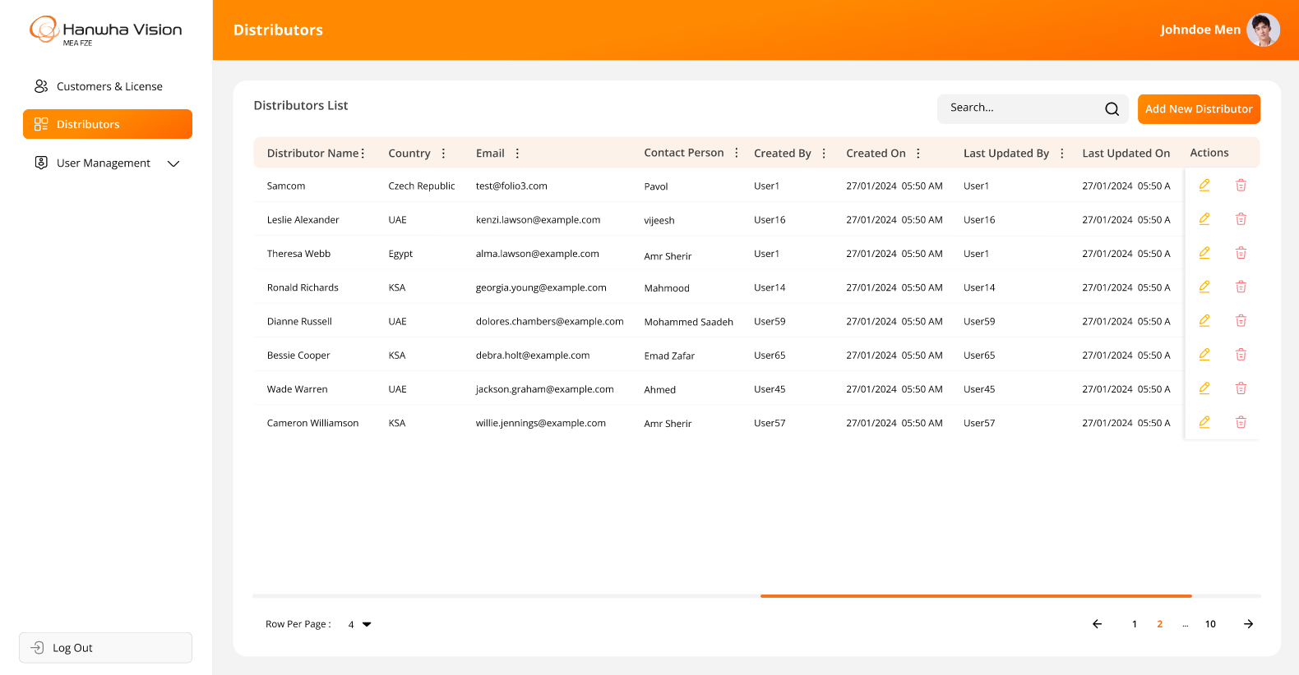
- The screen below represents the form for creating a new distributor in the Bi Dashboard Web Application, allowing users to enter relevant details and submit the information:
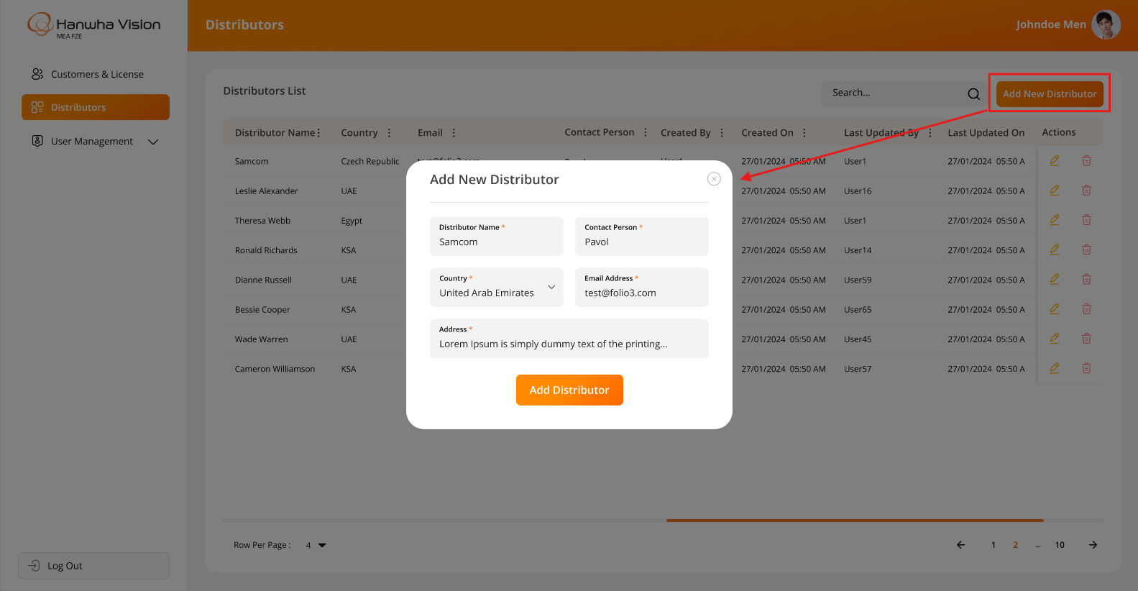

- The screen below displays the form for editing an existing distributor in the Bi Dashboard Web Application, allowing users to modify relevant details and update the information:
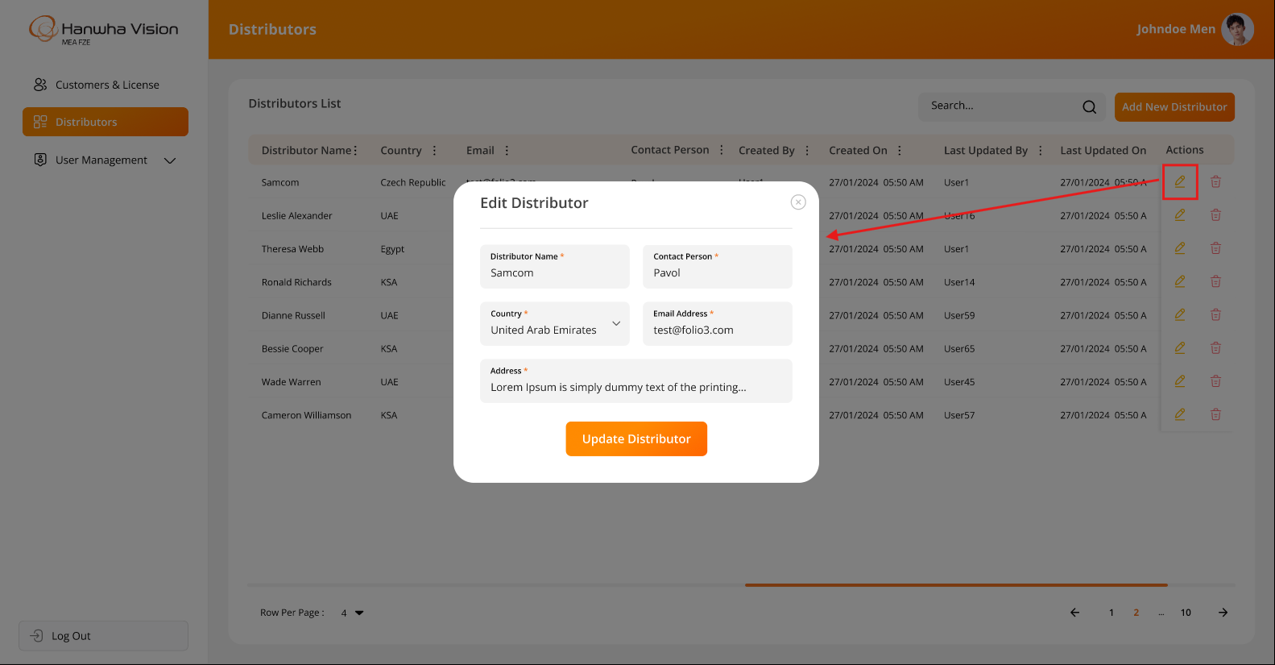

- The system will prompt a confirmation message when a user attempts to delete a distributor, ensuring that the action is intentional before proceeding:
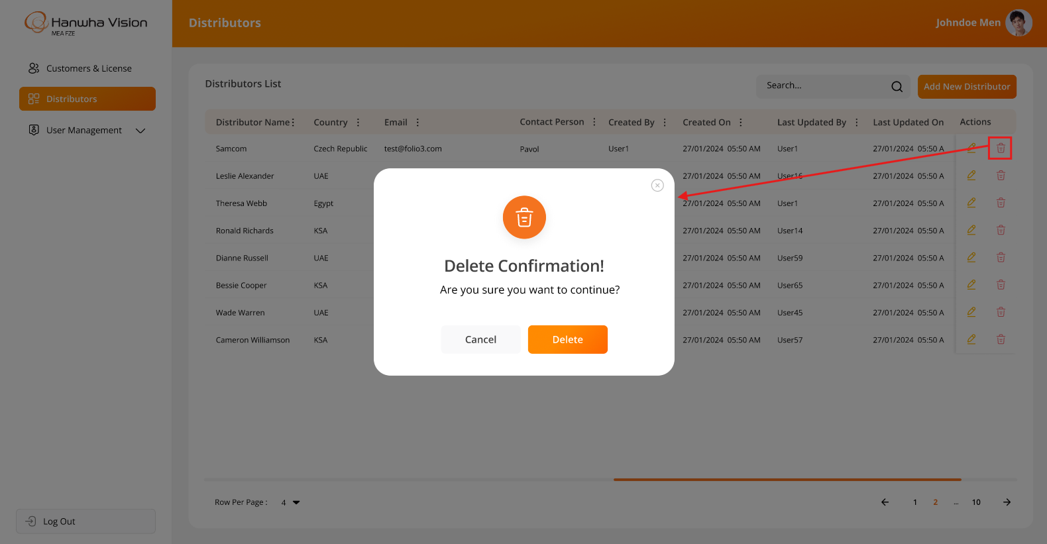

Business Rules:
- The system will display information and functionality strictly as per the above attached screenshots.
- Authorized users will have the ability to create and update distributors within the system.

Data Dictionary:

System Architecture

- The image below represents the flow of the entire system architecture, including all applications such as the Bi Dashboard Web Application, BI Dashboard Web Application, and the backend middleware for both applications:

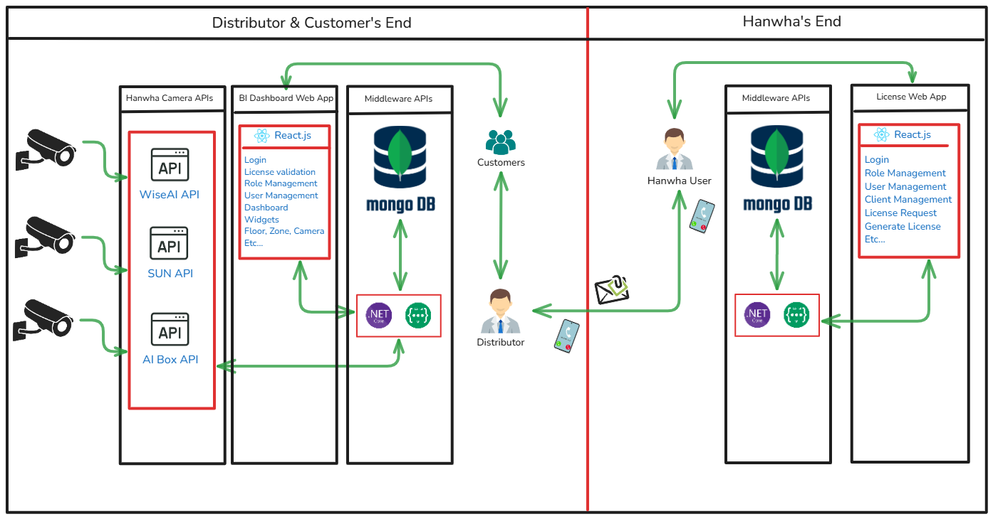

- The architecture below represents the flow of Backend Development Using .NET Core + Web API:

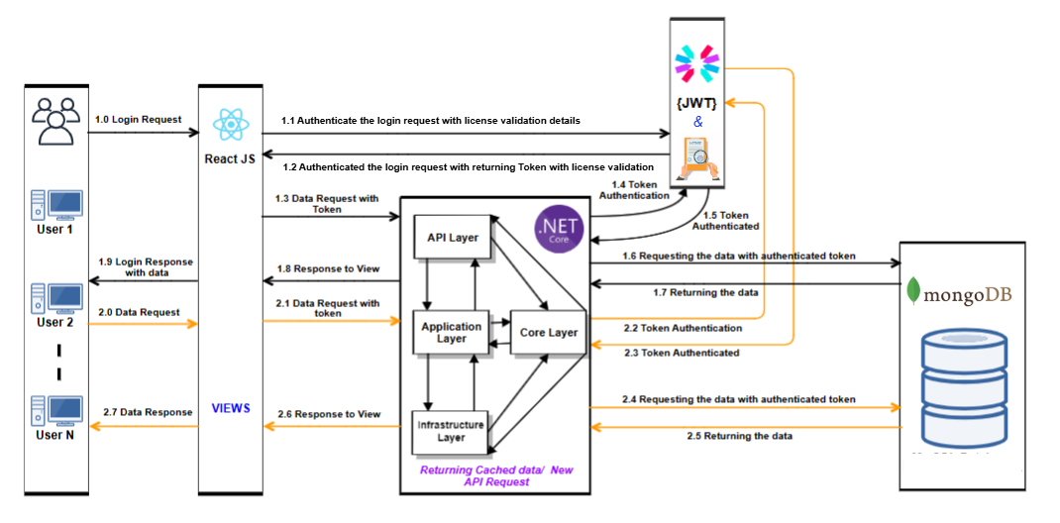
- The architecture below represents the flow of Frontend Development Using React.js Technology:

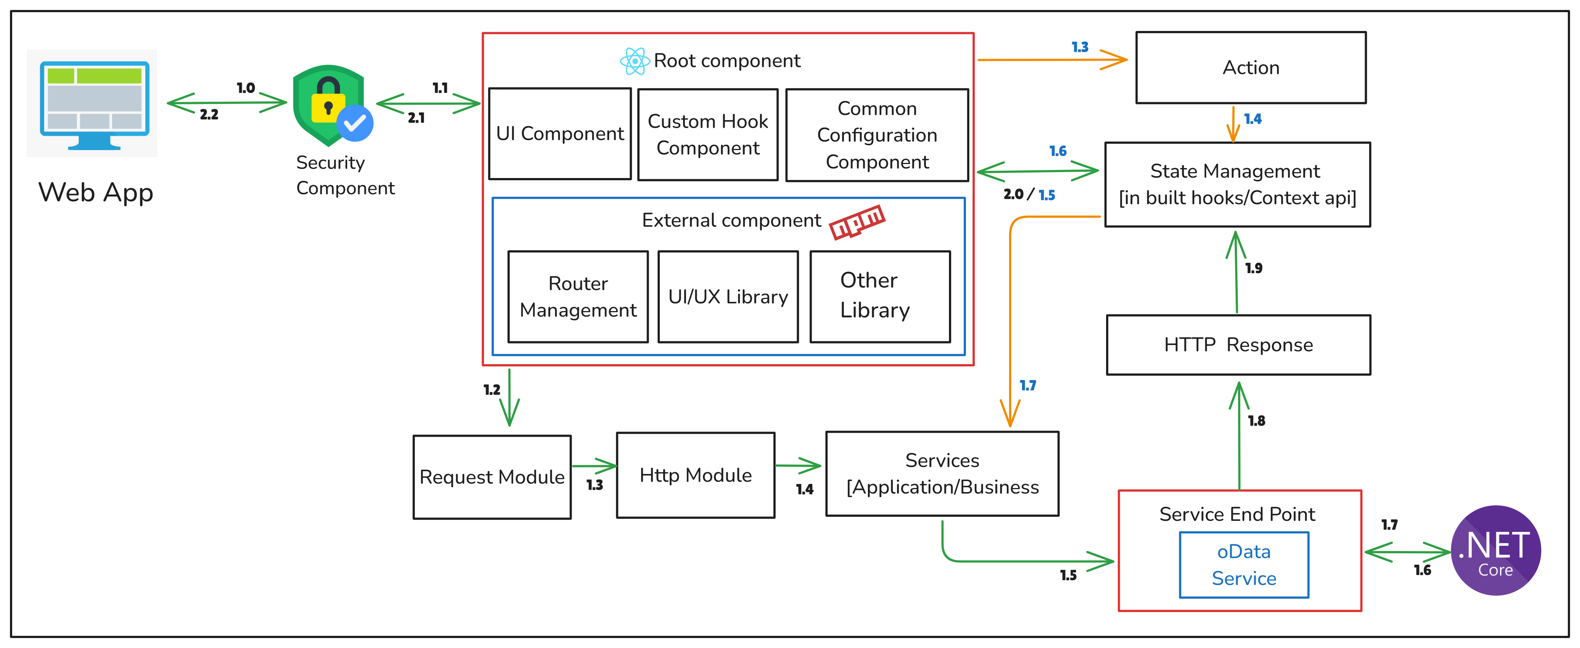

Assumptions, Dependencies and Constraints

- Any type of Server hosting fees, license cost, any other 3rd party API/SDK fees are not part of
development cost and will be procured and paid by client.
  - SPEC will have no liability for hardware failure deployed when running the proposed solution. Hence, the client should only take up relevant issues with the provider for the respective system.
  - Designs showcased in this SRS document as well as the ones shown to the client during the project query discussion calls will be considered as the final designs.
  - SPEC INDIA will not be responsible for any sort of server setup on the client’s UAT or Production Environment.
  - Database administration activities will not fall under the responsibility of SPEC INDIA team.
  - Once the application is live in Production, the database maintenance plan must be configured from the client’s end.
  - SPEC INDIA will not be responsible for any Point-in-Time Database Recovery/DR Drill/Database Upgrade/ Maintenance tasks etc.
  - The details are prepared based on the client's discussion; hence, changes may be made after completing the requirements study, which may require discussions under the change management process.
  - Any delay in the project schedule due to decision-making, data gathering, or approvals from the client side should be handled at the client's side. SPEC INDIA won’t be responsible for adding more resources for early completion in such scenarios.
  - The warranty period will automatically start ten days after the UAT rollout of both the applications (Client Web App & License Web App) & the warranty period will be 3 months.
  - After warranty completion, extra charges will be charged for knowledge transfer or documentation for/to another vendor.
  - The client will own the developed product and source code submitted after the final milestone payment.
  - A delay during any phase of the project by the customer will not be considered a delay by SPEC INDIA, and any payment milestone will not be delayed due to it.
  - Any delay in providing feedback or required dependency for more than two weeks will be escalated by SPEC INDIA.

---- end of document ----

